**Uncovering the Gaming Industry's Hidden Gems: A Comprehensive Analysis of Video Game Sales**

INTRODUCTON

Overview:

The video game industry is a rapidly growing and constantly evolving sector, with new games and technologies being developed and released every year. While blockbuster titles from major publishers often receive the lion's share of attention and sales, there are also many hidden gems within the industry that may not receive the same level of recognition but still offer unique and engaging experiences for players.

Purpose:

Additionally, we will discuss the importance of indie game developers and how their contributions to the industry can help to drive innovation and creativity.

Through this analysis, we hope to shed light on the hidden gems of the gaming industry and showcase the diverse range of experiences that are available to players beyond the mainstream titles. By highlighting the success of these games, we aim to encourage further exploration and discovery within the industry and support the continued growth and evolution of gaming as a medium for entertainment and artistic expression.

Prablem Definition and Design Thinking:

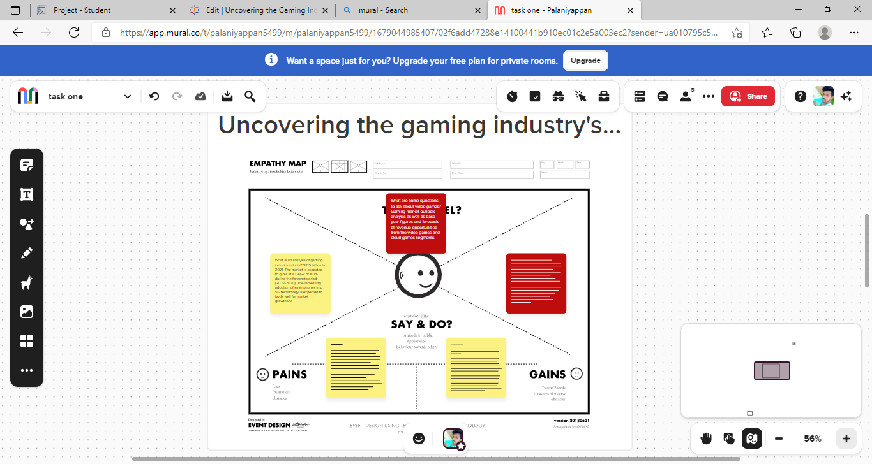

Results:

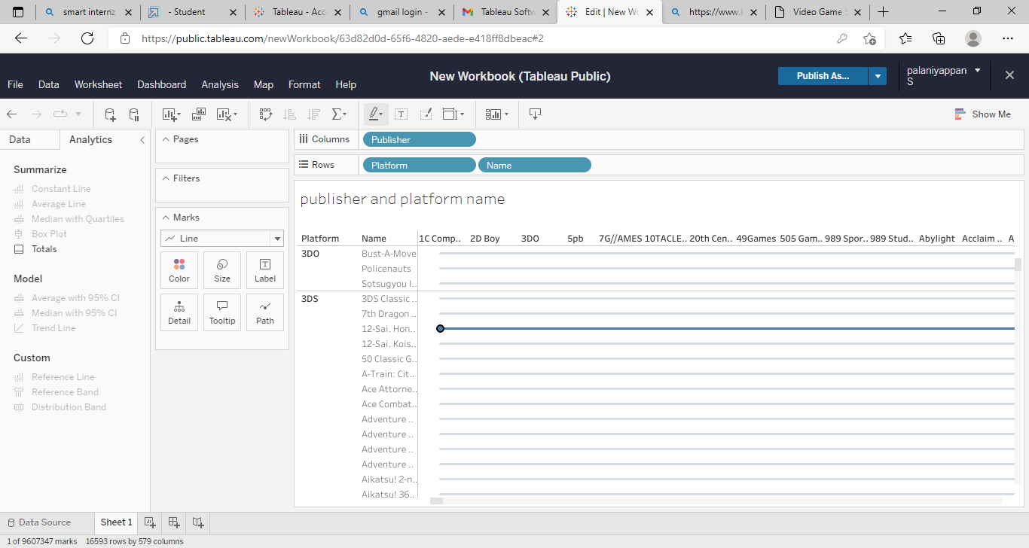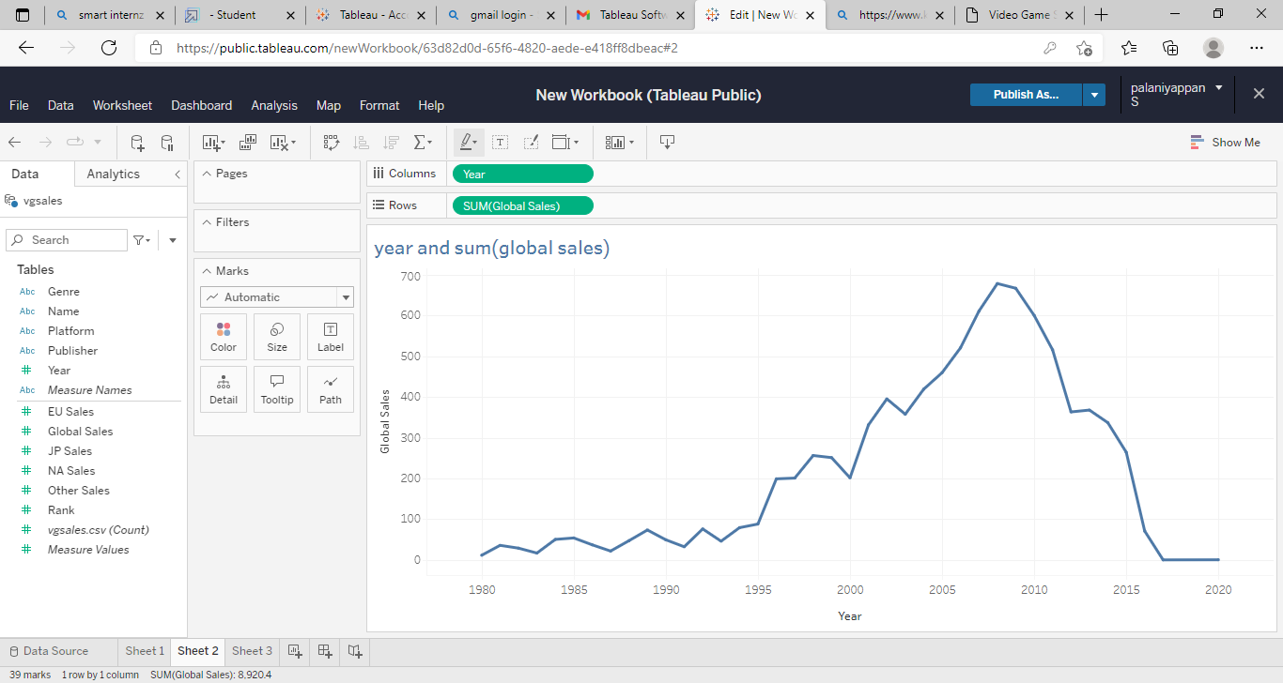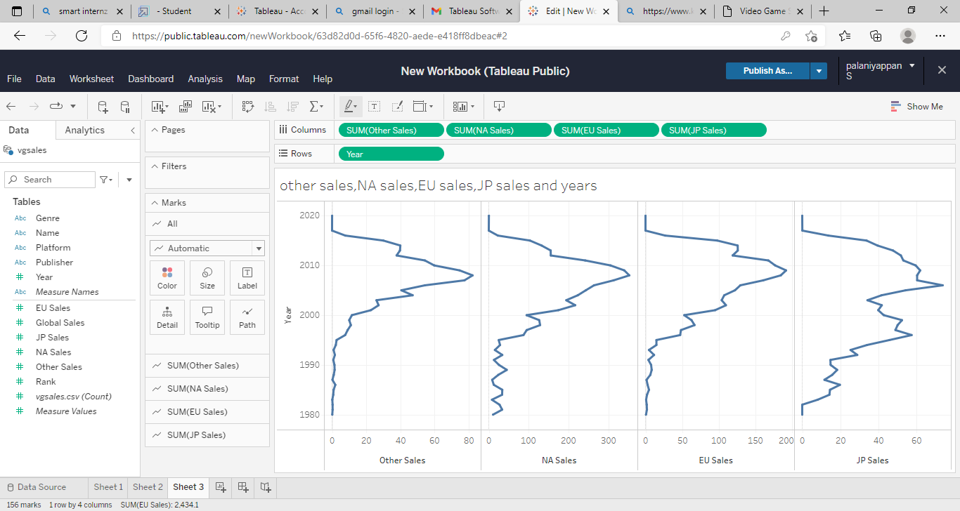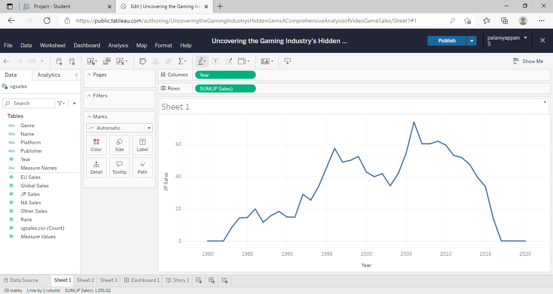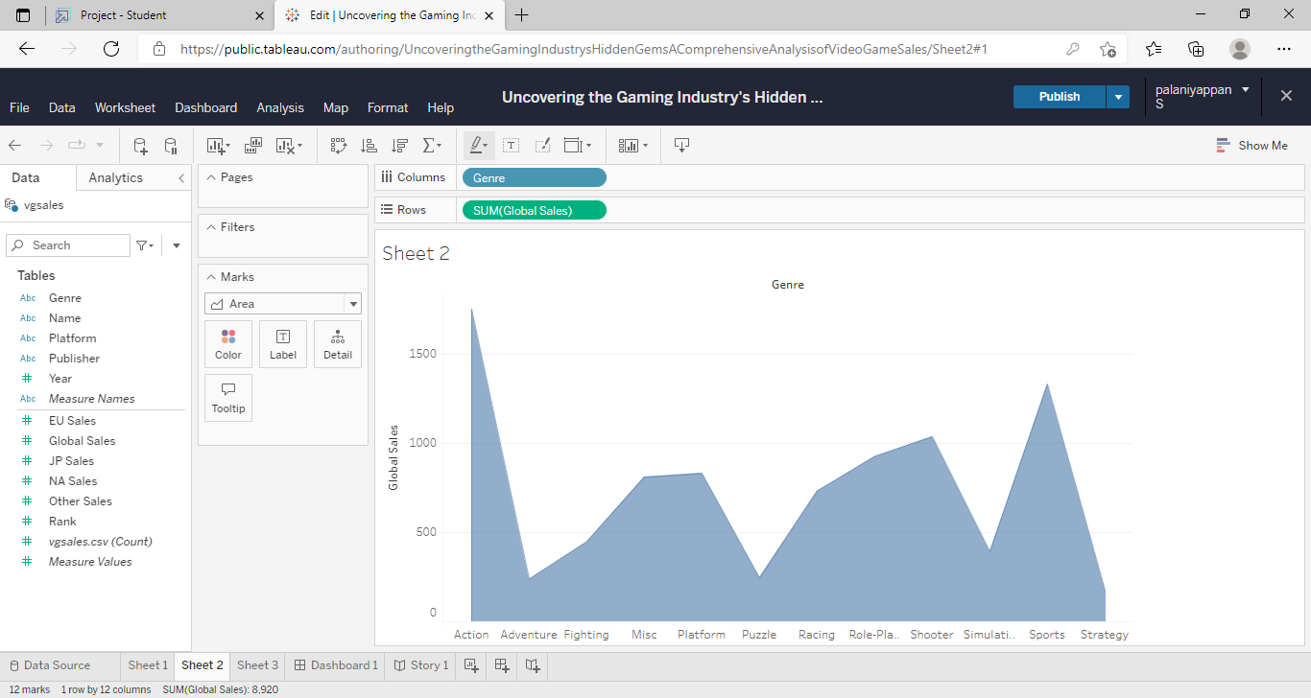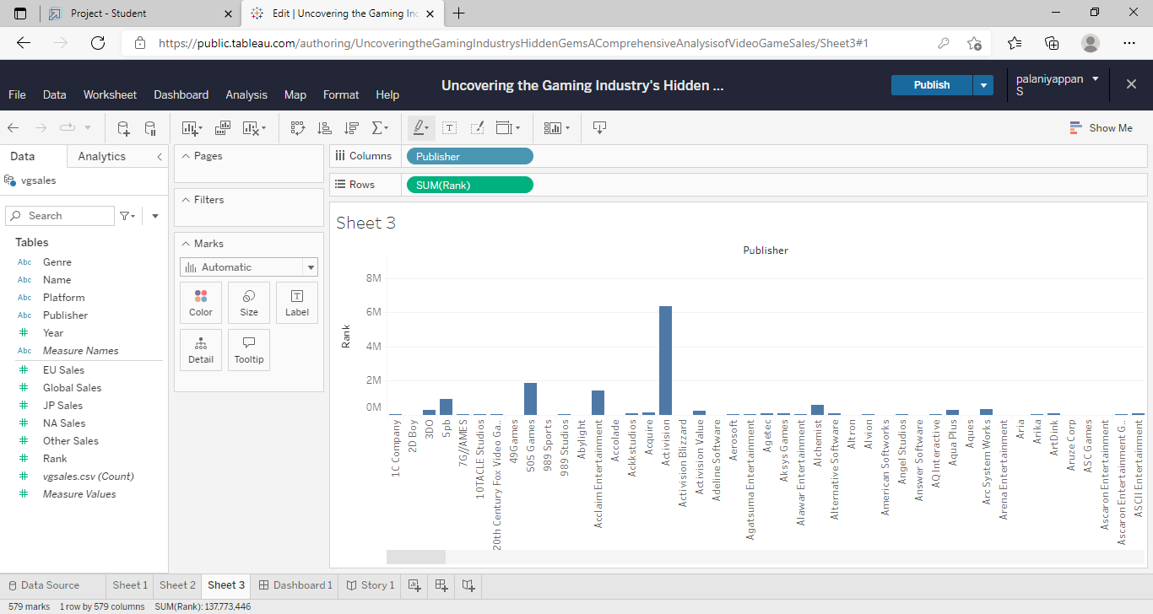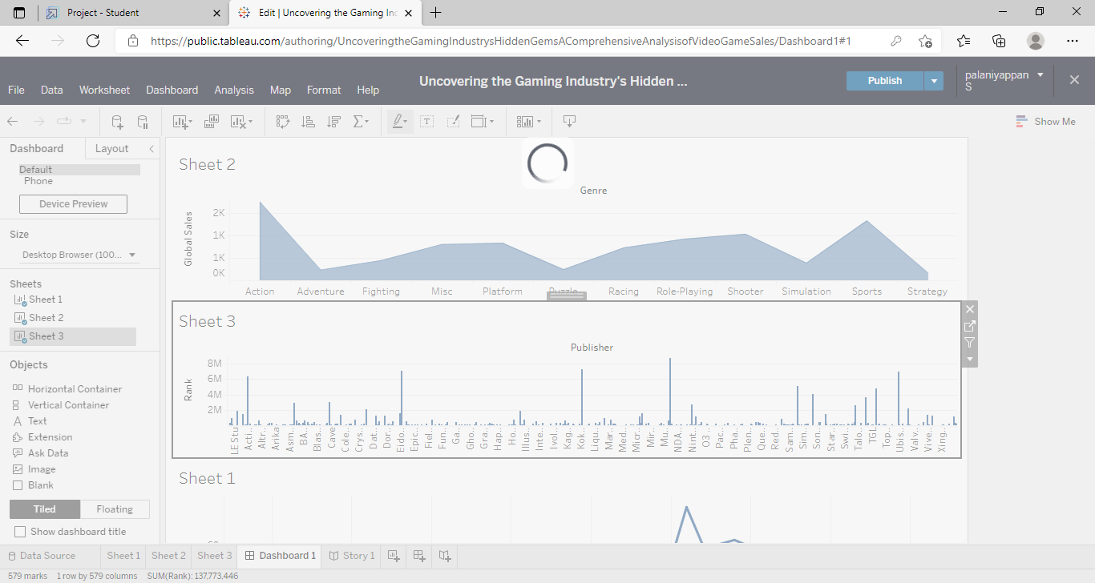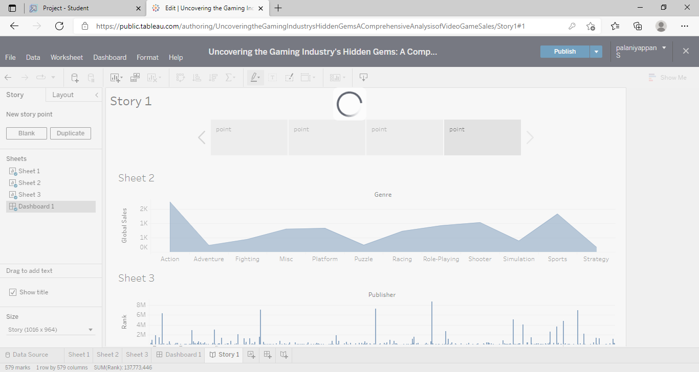

Advantages:

* Game industry growing market
* Attention or marketing providing gamer
* Spending billions of dollars
* To conduct comprehensive analysis
* Another way to identify hiden gemes

Disadvantages:

The video game indetry vast and dynamic market

* While major block buster titles
* One of the main challenges of hidden gems
* In terms of regional markets asia pacific largest market

Applications:

* Literature Review
* Conceptual Framework
* Analysis and Finding
* Time Series Modeler

Conclusion: Video game sales analysis is the process of collecting and analying data about the sales of video games in order to understand maeket trends

Future scope:

* Improve game industry
* To examine the evolusion of gaming in indid
* To analysis the state of gaming industry in india
* To analysisthe future growth prospects of gaming industry in india